## CHIP - Development notes

### About CHIP

The [Country Health Information Platform (CHIP)](https://espen.afro.who.int/tools-resources/chip) is a publically accessible PowerBI dashboard that provides national NTD programmes in the WHO AFRO region with quick analytical insights for common programmatic data questions.

CHIP is built using data submitted annually by all national NTD programmes through the WHO Joint Application Package (JAP) and Trachoma Elimination Monitoring Form (TEMF). These source data forms can be found here:

Joint Application Package (JRSM, JRF, EPIRF): <https://www.who.int/teams/control-of-neglected-tropical-diseases/preventive-chemotherapy/joint-application-package>

Trachoma Elimination Monitoring Form: <https://www.trachoma.org/zithromax-management-guide>

Reported data via these forms are imported into CHIP from the NTD data analytic files housed on the ESPEN Portal via API. Full details of the ESPEN APIs can be found here:

ESPEN API: <https://admin.espen.afro.who.int/docs/api>

Due to this reporting model, CHIP has no data input or storage requirements. Any reporting gaps or data errors in CHIP will therefore require resubmission of the JAP/TEMF and a refresh of the respective country dashboard to activate in the live site.

CHIP data reporting model

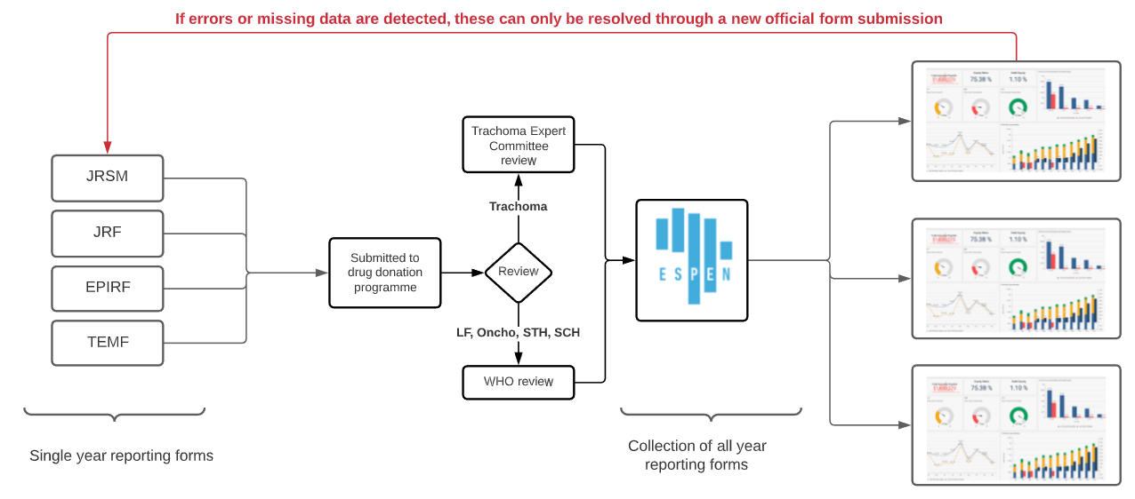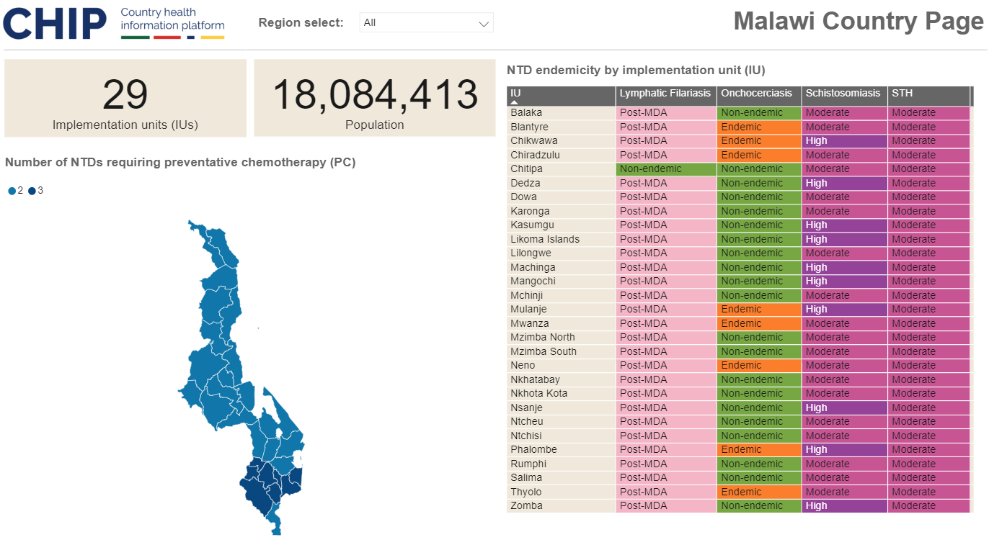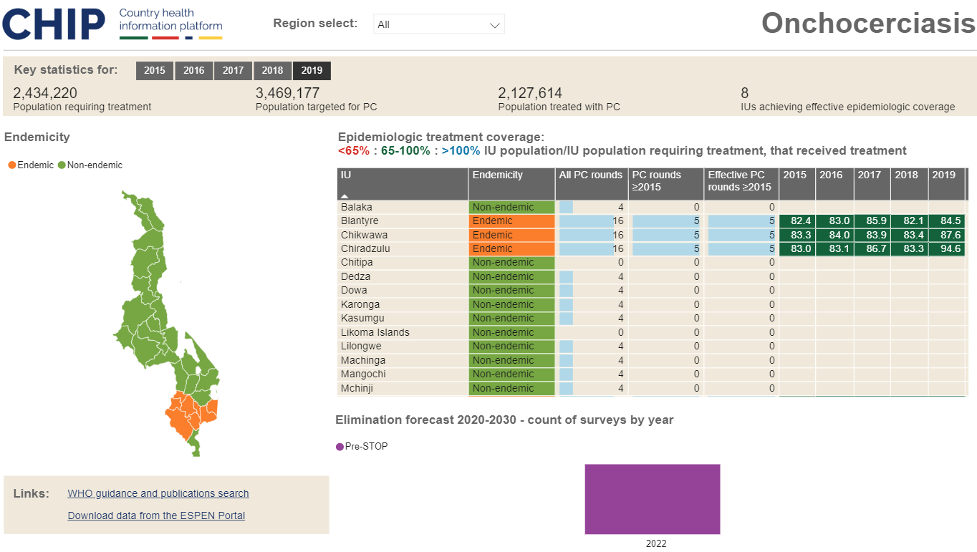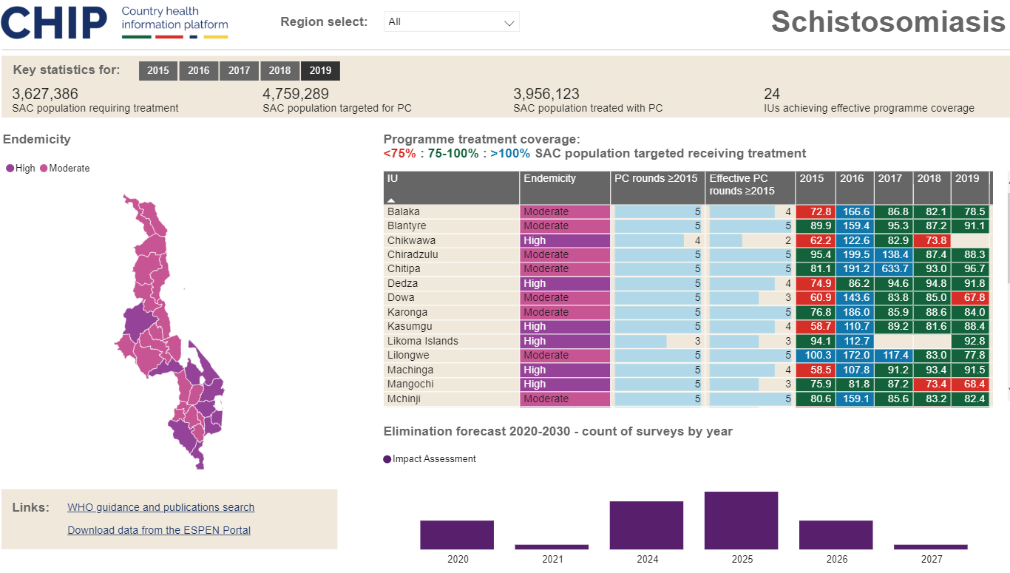

### CHIP design model notes

Chip is constructed from the ESPEN data API.

ESPEN data for LF, OV, SCH and STH utilise one unique IU-level geographic coding system: the ESPEN ID. This geography is central to the design CHIP model, and forms the hub from which other data tables per disease link.

As trachoma uses a different coding system, the model here is replicated using the GeoConnect IU/EU-level geographic coding system.

Due to ongoing re-districting which create historic data discordance, CHIP V1 defaults to the administrative geography of the current reporting year in each disease specific page. IUs from the last 5 years which are archived (i.e., no longer feature), or have been re-numbered due the scope of administrative boundary changes, are therefore filtered out[1]. This has been actioned primarily due to discordance in filtering endemicity maps by their legend entries where endemicity has changed over time.

Current endemicity status and the latest count of treatment rounds (total/non-effective) are sourced using summary tables per each disease called MAX_Yr. This ensures consistency between status as per maps and summary table visualisations.

Note that how historic data is represented in CHIP will be re-visited, and a refined model developed for future CHIP upgrades that will seek to restore to the disease-specific pages any coverage data from archived IUs.

CHIP accordingly contains the following data tables:

|  |  |  |
| --- | --- | --- |
| Table Name | Description | API Parameters |
| Geography | ESPEN administrative geography (LF, OV, SCH, STH) | - |
| Geography_TRA | GeoConnect administrative geography (TRA only) | - |
| Country_Page | Country level co-endemicity data | IOS2=County code  Disease = coendemicity  Level=iu |
| JAP_Status | Historic status of JAP and JRSM submission. | IOS2=County code  Type=jap  Subtype=submission |
| LF_Page | Historic LF reported treatment data. | IOS2=County code  Disease = lf  Level=iu |
| LF_MAX_Yr | Summary table of endemicity and count of treatment rounds from current reporting year. | - |
| LF_Page_forecast | Forecasted LF surveys 2020-2030. | IOS2=County code  Disease = lf  Level=iu  Type=forecast |
| Oncho_Page | Historic oncho reported treatment data. | IOS2=County code  Disease = oncho  Level=iu |
| Oncho_MAX_Yr | Summary table of endemicity and count of treatment rounds from current reporting year. | - |
| Oncho_Page_forecast | Forecasted oncho surveys 2020-2030. | IOS2=County code  Disease = oncho  Level=iu  Type=forecast |
| SCH_Page | Historic SCH reported treatment data. | IOS2=County code  Disease = sch  Level=iu |
| SCH_MAX_Yr | Summary table of endemicity and count of treatment rounds from current reporting year. | - |
| SCH_Page_forecast | Forecasted SCH surveys 2020-2030. | IOS2=County code  Disease = sch  Level=iu  Type=forecast |
| STH_Page | Historic STH reported treatment data. | IOS2=County code  Disease = sth  Level=iu |
| STH_MAX_Yr | Summary table of endemicity and count of treatment rounds from current reporting year. | - |
| STH_Page_forecast | Forecasted STH surveys 2020-2030. | IOS2=County code  Disease = sth  Level=iu  Type=forecast |
| Trachoma_Page | Historic trachoma reported treatment data. | IOS2=County code  Disease = trachoma  Level=iu |
| Trachoma_MAX_Yr | Summary table of endemicity and count of treatment rounds from current reporting year. | - |
| Trachoma_Page_forecast | Forecasted trachoma surveys 2020-2030. | IOS2=County code  Disease = oncho  Level=iu  Type=forecast |
| WASH_Page | Country level WASH data | IOS2=County code  Disease = coendemicity  Level=iu |
| WASH_NTD_Cat | SCH/STH prevalence categories | Custom table |

### Endemicity status recoding

Endemicity IUs as per ESPEN data has been simplified for CHIP visualisation.

For LF and oncho, the coding categorisation of ‘Endemic (under MDA)’ and ‘Endemic (MDA not delivered)’ has been aligned as ‘Endemic.’ In all cases ‘Unknown’ and ‘Not reported’ have been aligned as ‘Unknown.’ This is to limit the count of categories/colours to be presented in visualisations at any one time.

See CHIP - Codebook for further details.

### Notes on cartography

CHIP defaults to the administrative geography of the current reporting year. All cartography is downloaded in shapefile format from the [ESPEN cartography database](https://espen.afro.who.int/tools-resources/cartography-database) and converted to the .topojson format required for PowerBI ShapeMap visual use using [Mapshaper](https://mapshaper.org/).

Due to the ‘stacked’ construction of GeoConnect shapefiles for trachoma, prior to incorporation in CHIP, shapefiles may have been adjusted to remove ‘parent’ IUs. These would otherwise obscure ‘child’ IUs in the trachoma map and prevent cross-selection of IU/EUs between endemicity maps and summary table.

### Additional resources

|  |  |
| --- | --- |
| Resource | Description |
| CHIP - Codebook | All endemicity codes used in CHIP and associated colour HEX codes. |
| CHIP - Onboarding new countries protocol | Process for building a new CHIP dashboard and publishing to live. |
| CHIP - Country refresh protocol | Process for refreshing a CHIP dashboard annual/on request. |

1. Note that ongoing counts of treatment rounds/effective treatment rounds are transferred to the new cartography when updated.